Articles & book chapters published in 2025
"Let the Lead Tags Talk—Terms on Carnuntum Tesserae Referring to Textiles, Colours and Dyeing in the 2nd Century CE"
Regina Hofmann-de Keijzer, Ivan Radman-Livaja, Ines Bogensperger, Andreas G. Heiss and Beatrix Petznek
Heritage, 2025, 8(10), 412.
Read more here: https://doi.org/10.3390/heritage81004122
Published online - 01/10/2025.
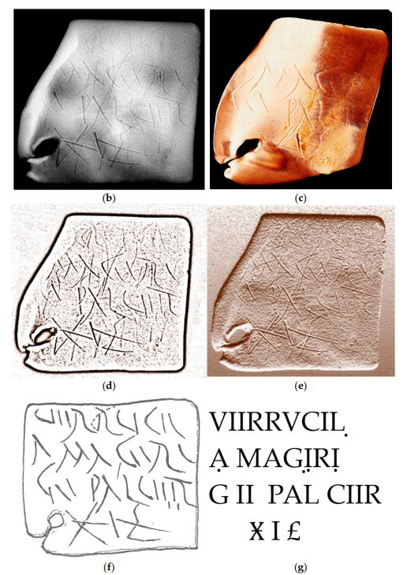
"Multiband photogrammetry for multispectral 3D reconstruction of statuary"
Daniele Ferdani, Cristiana Barandoni, Federica Bonifazi, Roberta Iannaccone and Donata Magrini
Journal of Cultural Heritage, 2025, 76, 74-85.
Read more here: https://doi.org/10.1016/j.culher.2025.09.003
Published online - 19/09/2025.
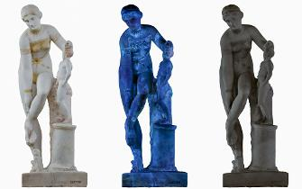
"Egyptian Blue in the Polychromy of the Acropolis Monuments: An Analytical Investigation"
Eleni Aggelakopoulou, Anastasia Panou, Katerina Frantzikinaki, Asterios Bakolas, Christos Papatrechas
Journal of Raman Spectroscopy, 2025, 1-12.
Read more here: https://doi.org/10.1002/jrs.70017
Published online - 13/07/2025.
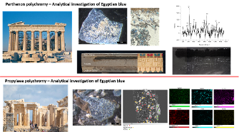

"Identification of Shellfish Blue on an Ancient Egyptian (Dynasty XVIII) Painted Votive Textile"
Jennifer Poulin, Margaret-Ashley Veall and Chris Paulocik
Heritage, 2025, 8(7), 257.
Read more here: https://doi.org/10.3390/heritage8070257
Published online - 01/07/2025.

"Ochres as earth pigments in Hellenistic and Roman polychromy: State of the art and future directions on material origins and trade"
Ariadne Marketou and Alexandra Rodler
Journal of Archaeological Science, 2025, 180, 106276.
Read more here: https://doi.org/10.1016/j.jas.2025.106276
Published online - 30/05/2025.
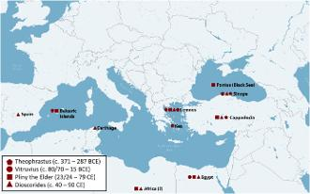

"Assessment of process variability and color in synthesized and ancient Egyptian blue pigments"
John S. McCloy, Edward P. Vicenzi, Thomas Lam, Julia Esakoff, Travis A. Olds, Lisa S. Haney, Mostafa Sherif, John Bussey, M. C. Dixon Wilkins & Sam Karcher
npj Herit. Sci. 2025, 13, 202.
Read more here: https://doi.org/10.1038/s40494-025-01699-7
Published online - 22/05/2025.

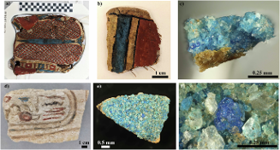
"Illuminating the Parthenon"
Juan de Lara
Annual of the British School at Athens, 2025, 1–46.
Read more here: https://doi.org/10.1017/S0068245424000145
Published online - 06/05/2025.
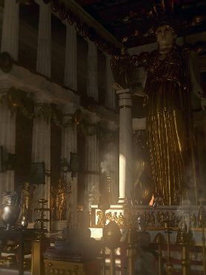

"Pigments from Pasargadae and Persepolis in the Metropolitan Museum of Art (NY): recent scientific investigations on four paper squeezes"
Atefeh Shekofteh, Alexander Nagel and Omid Oudbashi
Conservar Património, 2025
Read more: https://doi.org/10.14568/cp35708
Published online - 27/04/2025.

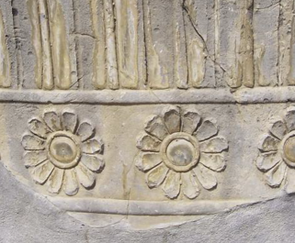
"Reimagining Greco-Roman Art in Colour: A Screen-Based Exhibition Interactive at the National Museum of Australia."
Lily Withycombe
in Candace Richards and Elizabeth Minchin (eds), Mediterranean Collections in Australia and Aotearoa New Zealand. Routledge, 2025, pp.251-261.
More information here.
Published online - 04/04/2025.
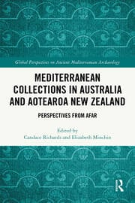

"A study of the polychromy of Campana’s panels"
Ombretta Tarquini, Elena Gabriella Lorenzetti, Lucilla Pronti and Anna Candida Felici
Conservar Património, 2025
Read more: https://conservarpatrimonio.pt/article/view/36608
Published online - 21/03/2025.
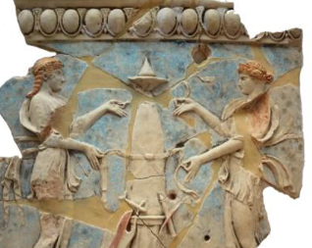

"Mineralogical and Micro-Computer Tomographic (μCT) Texture Investigations of Egyptian Blue Spheres (Aguntum, East Tyrol; Retznei and Wagna, Flavia Solva, South Styria)"
Gerald Degenhart, Julius Heinemann, Peter Tropper, Alexandra Rodler-Rørbo, Bianca Zerobin, Martin Auer, and Gert Goldenberg
Minerals, 2025, 15(3) 302.
Read more: https://doi.org/10.3390/min15030302
Published online - 15/03/2025.
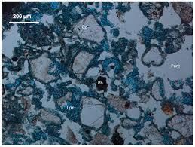

"Pompeian pigments. A glimpse into ancient Roman colouring materials"
Celestino Grifa, Chiara Germinario, Sabrina Pagano, Andrea Lepore, Alberto De Bonis, Mariano Mercurio, Vincenzo Morra, Gabriel Zuchtriegel, Sophie Hay, Domenico Esposito, Valeria Amoretti
Journal of Archaeological Science, 2025, 177, 106201
Read more here: https://doi.org/10.1016/j.jas.2025.106201
Published online - 15/03/2025.
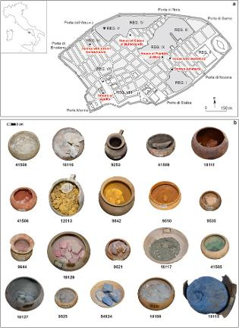

"Vitruvius-like synthesis of Egyptian Blue using Roman coins as copper source"
Maria Cristina Caggiani, Philippe Colomban, Ludovic Bellot-Gurlet, Paolo Mazzoleni, Germana Barone
Spectrochimica Acta Part A: Molecular and Biomolecular Spectroscopy, 2025, 336, 126029.
Read more: https://doi.org/10.1016/j.saa.2025.126029
Published online - 10/03/2025.
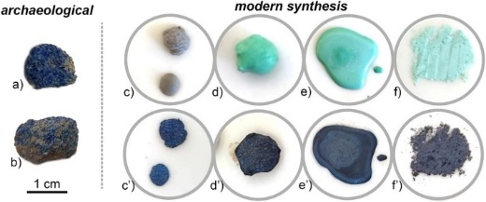

"The Scent of Ancient Greco-Roman Sculpture"
Cecilie Brøns
Oxford Journal of Archaeology, 2025,
Read more here: https://doi.org/10.1111/ojoa.12321
Published online - 03/03/2025.

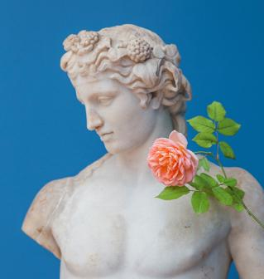

"Polychromy on Roman Sarcophagi from Rome. Key Aspects and
Foundations for Future Collaborations in Provincial Context"
Eliana Siotto
in Montserrat Cleveria and Markus Trunk (eds), Conditoria Provinciarum. Roman Sarcophagi in the Provinces, Iberica Selecta 3, Franz Steiner Velarg, Stuttgart, 2025, pp. 331-356.
More information here.
Published - 06/02/2025.
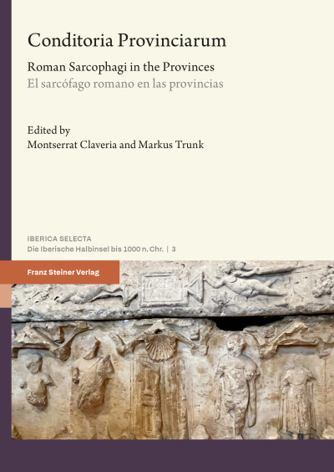

"From tiny to immense: Geological spotlight on the Alexander Mosaic (National Archaeological Museum of Naples, Italy) using non-invasive in situ analyses"
Balassone G, Cappelletti P, De Bonis A, De Simone A, Di Martire D, et al.
PLOS ONE, 2025, 20(1): e0315188.
Read more here: https://doi.org/10.1371/journal.pone.0315188
Published online - 15/01/2025.
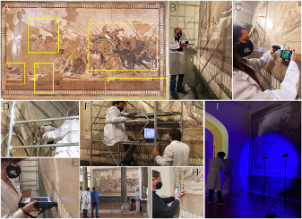

"Unveiling the Original Polychromy of Archaic Architecture: The Gigantomachy on the West Pediment of the Temple of Apollo at Delphi (6th c. B.C.)"
Giasemi G. Frantzi, Georgios P. Mastrotheodoros, Panayiotis Theoulakis, Sotiria Kogou, Athanasia Psalti and Hariclia Brecoulaki
Heritage, 2025, 8(1), 17-26.
Read more here: https://doi.org/10.3390/heritage8010017
Published online - 06/01/2025.
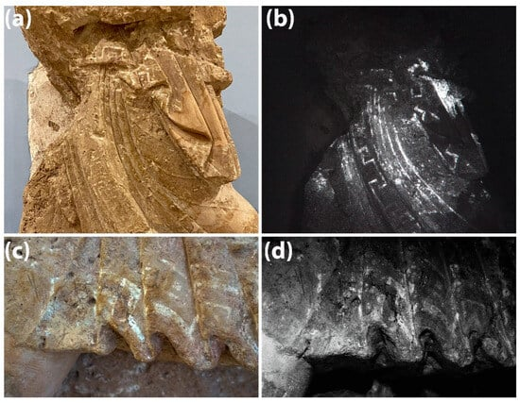

"Cinnabar for Roman Ephesus: Material quality, processing and provenance"
Alexandra Rodler-Rørbo et al.
Journal of Archaeological Science, 2025, 173, 106122.
Read more here: https://doi.org/10.1016/j.jas.2024.106122
Published online - 26/11/2024.
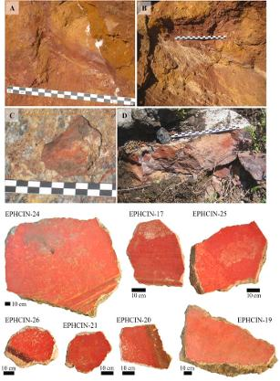

Books published in 2025

"Colour & Space. Interfaces of Ancient Architecture and Sculpture -Proceedings of the 10th Inter-national Round Table on Polychromy in Ancient Sculpture and Architecture"
Edited by Frederik Grosser and Stephan Zink
Published by DAI/Reichert Verlag
The compilation of the contributions to the "10th International Round Table on Polychromy in Ancient Architecture and Sculpture" (Berlin 2020) focuses on the phenomenology of colour in architectural and sculptural contexts. On the basis of case and overall studies from Greco-Roman antiquity to the Middle Ages, the effect of polychromy in spatial contexts is examined. In addition, it explores how colour enhances form and alters meanings, and explores artistic and technological practices. Overall, the volume argues for an interdisciplinary perspective on paint and surface treatment.
More details (including table of contents) here.
Available open-access here.
Published - 14/10/2025.
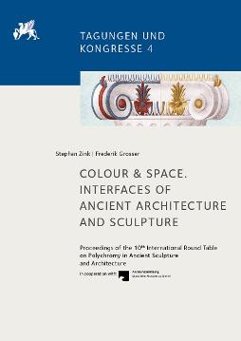

"Chroma. Sculpture in Color from Antiquity to Today"
Edited by Seán Hemingway, Sarah Lepinski and Vinzenz Brinkmann
Published by The Metropolitan Museum of Art/Distributed by Yale University Press
This volume features new research by more than thirty international experts in polychromy, including art historians, conservators, scientists, and photographers. Identified through advanced technologies, scientific analyses, and in-depth research, their discoveries of surviving traces of color span the globe and vary in material, including an Archaic Greek marble sphinx, an ancient Phoenician cloisonné furniture plaque, Mexica (Aztec) lime-stone sculptures, and medieval and Renaissance European marbles and bronzes.
More details (including table of contents) here.
Published - 29/07/2025.
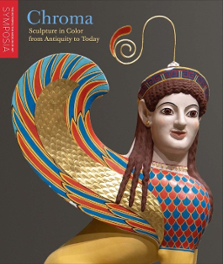

"Colour Schemes in Roman Architecture. Aesthetics, Semantics, and Regional Appropriation"
Johannes Lipps and Matthias Grawehr (Editors)
Published by Reichert Verlag
Roman architecture was characterised by a rich palette of colours, achieved through the use of natural coloured stones and painting. This conference volume is the first book entirely dedicated to the polychromy of architectural orders in the Roman provinces. Its objectives are to present new data, to explore the visual effects for which colour was used on architectural elements, and to collate observations on the functional, chronological and regional variation. The volume brings together the contributions of twenty-five archaeologists, ancient historians, art historians and chemists, encompassing a wide chronological frame from the 2nd century BC to the 3rd century AD and covering a geographical range from modern Spain, France, Switzerland, Italy, and Austria to Turkey, Cyprus, Lebanon, and Libya.
More details here.
Published - 2025.
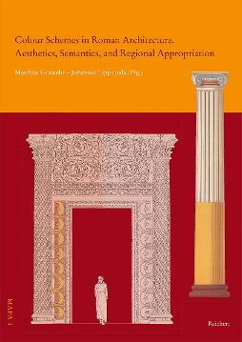

"Blue by Fire: A Marker of the Technical History of Glass and Ceramics"
Howell G. M. Edwards and Philippe Colomban
Published by Springer Nature
This book addresses the application of elemental and molecular spectroscopic analytical techniques to a range of diverse problems which arise for decorated ceramics, glass and enamels and related artefacts: a history of techniques, provenance and authentication.
Includes a chapter on Blue Pigments in Antiquity.
More details here.
Published - 28/01/2025.


Articles & book chapters published in 2024

"Archaeometric Study of the Colorants in the Finds From the 4th Century BC Cist Tomb at Lakkoma, Chalcidice"
Svetlana Vivdenko, Athina Vasileiadou, Maria Tsimbidou-Avlonitou, Alexandros Konstanta, Lydia Avlonitou, Nikolaos Zacharias
J Raman Spectrosc, 2024, 55, 1322-1332
Read more here: https://doi.org/10.1002/jrs.6754
Published online - 28/11/2024.

"Cinnabar for Roman Ephesus: Material quality, processing and provenance"
Alexandra Rodler-Rørbo et al.
Journal of Archaeological Science, 2025, 173, 106122.
Read more here: https://doi.org/10.1016/j.jas.2024.106122
Published online - 26/11/2024.

"Tooth for tooth: The shining white smile of the large bronzes"
Ute Peltz
Dissertationes Archaeologicae, 2024, 53–73.
Read more here: https://doi.org/10.17204/dissarch.suppl4.53
Published online - 30/09/2024.
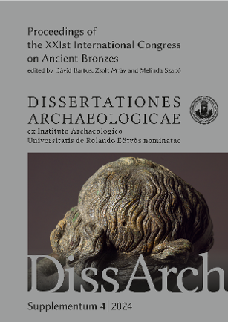

"Analytical methodological adaptations for sampling ancient pigments in provenance research"
Alexandra Rodler-Rørbo, Cecilie Brøns, Nathalie Tepe, Alicia Van Ham-Meert, Gilberto Artioli, Robert Frei, Thilo Hofmann, Christian Koeberl
Journal of Cultural Heritage, 2024, 69, 126-134.
Read more here: https://doi.org/10.1016/j.culher.2024.08.004
Published online - 31/08/2024.
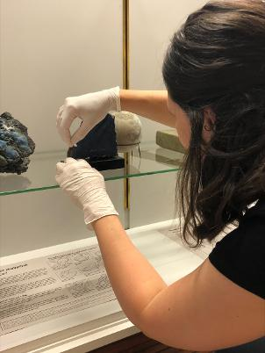

"Facing death: a multidisciplinary analysis of a Romano-Egyptian mummy mask at the Ny Carlsberg Glyptotek, Copenhagen."
Tuuli Kasso, Jens Stenger, Caterina Zaggia, Gianluca Pastorelli, Max Ramsøe, Tina Ravnsborg, Ole N. Jensen, Elsa Yvanez, Chiara Spinazzi-Lucchesi, Matthew J. Collins and Cecilie Brøns
Heritage Sci, 2024, 12, 250.
Read more here: https://doi.org/10.1186/s40494-024-01354-7
Published online - 23/07/2024.
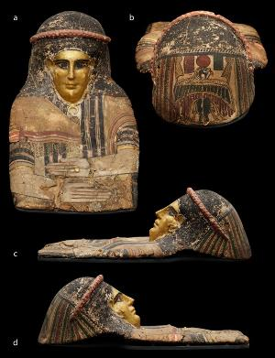
"Investigating Organic Colorants Across Time: Interdisciplinary Insights into the use of Madder, Indigo/Woad, and Weld in Historical Written Sources, Archaeological Textiles, and Ancient Polychromy"
Paula Nabais, Cecilie Brøns, and Magdalena M. Wozniak
In Textile Crossroads: Exploring European Clothing, Identity, and Culture across Millennia. Anthology of COST Action “CA 19131 – EuroWeb”. Kerstin Droß-Krüpe, Louise Quillien, & Kalliope Sarri, Editors. Zea Books, Lincoln, Nebraska, 2024. DOI:
Read more here: https://doi.org/10.32873/unl.dc.zea.1806
Published online - 09/07/2024.

"A new approach to locate, characterise and restore in 3D polychromy of Apollo’s temple at Delphi (4th century B. C.)"
Vincent Baillet, Rémy Chapoulie, Bruno Dutailly, Francesca Galluzzi, Pascal Mora and Aurélie Mounier
Digital Applications in Archaeology and Cultural Heritage, 2024, e00345.
Read more here: https://doi.org/10.1016/j.daach.2024.e00345
Published online - 07/06/2024.
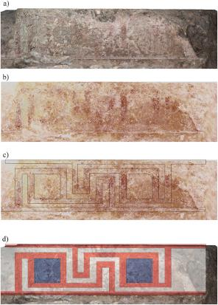

"Investigating polychromy on the Parthenon’s west metopes"
Eleni Aggelakopoulou and Asterios Bakolas
Archaeol Anthropol Sci, 2024, 16, 96.
Read more here: https://doi.org/10.1007/s12520-024-01996-5
Published online - 05/06/2024.

"Digital methods and techniques for reconstructing and visualizing ancient 3D polychromy – An overview"
Eliana Siotto and Paolo Cignoni
Journal of Cultural Heritage, 2024, 68, 59-85.
Read more here: https://doi.org/10.1016/j.culher.2024.05.002
Published online - 04/06/2024.
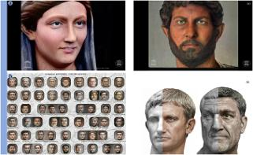

"Real-time identification and visualization of Egyptian blue using modified night vision goggles"
Marco Nicola, Roberto Gobetto, Alessandro Bazzacco, Chiara Anselmi, Enrico Ferraris, Alfonsina Russo, Admir Masic and Antonio Sgamellotti
Rend. Fis. Acc. Lincei, 2024.
Read more here: https://doi.org/10.1007/s12210-024-01245-w
Published online - 22/04/2024.


"Tracking Color Through Time: Polychromy on Etruscan Urns from Ancient Creation to Modern Intervention"
Cecilie Brøns, Jens Stenger, Anna Katerinopoulou, Katherine Eremin, Kate Smith, Georgina Rayner, Susanne Ebbinghaus, and Jacob Kveiborg
American Journal of Archaeology, 2024, Vol. 128, No. 2, pp. 167-197.
Read more here: https://doi.org/10.1086/728694
Published online - 15/03/2024.

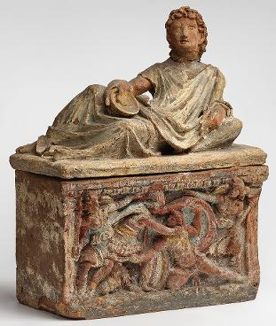

"Is Gold Yellow? Plant Dyes and Gold-Making in the Ancient Chemical Arts"
Caterina Manco and Matteo Martelli
Ambix, DOI: 10.1080/00026980.2024.2309061
Read more here: https://doi.org/10.1080/00026980.2024.2309061
Published online - 07/03/2024.
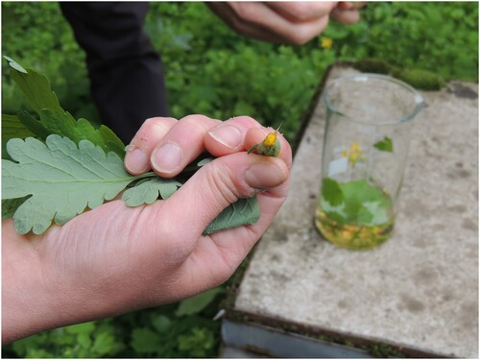

"Persepolis West: Evidence for a Pigment Production Site and its Connections with Achaemenid Royal-Official Buildings"
Emad Matin
Ancient Civilizations from Scythia to Siberia, 2024, 29(2), 262-306.
Read more here: https://doi.org/10.1163/15700577-20232911
Published online - 25/01/2024.
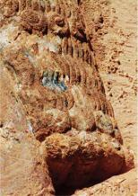

"Traces of Polychromies in Roman sculpture: a multi-analytical approach"
Sara Lenzi, Marta Novello, Monica Salvadori, Ivana Angelini, Alfonso Zoleo, Rita Deiana
Proceedings of the IMEKO TC4 International Conference on Metrology for Archaeology and Cultural Heritage, 2023, 132-136.
Read more here: https://doi.org/10.21014/tc4-ARC-2023.026
Published online
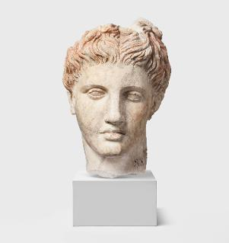

"The “Tomb of the Philosophers” in Pella, Macedonia Revisited: New Findings on Its Iconography"
Myrina Kalaitzi, Hariclia Brecoulaki and Giovanni Verri
Tekmeria, 2024, 18, 97-150.
Read more here: https://doi.org/10.12681/tekmeria.36631
Published online - 25/01/2024.
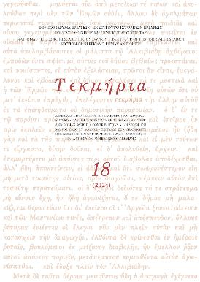
"Roman Britain in Colour – Roman Altars from Hadrian's Wall Reimagined"
Andrew Parkin
Theoretical Roman Archaeology Journal, 2024, 6(1), 1–19.
Read more here: https://doi.org/10.16995/traj.10192
Published online - 19/01/2024.
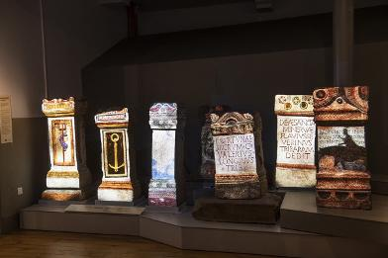

"Analyses of the brown stain on the Parthenon Centaur head in Denmark"
Kaare Lund Rasmussen, Bodil Bundgaard Rasmussen, Thomas Delbey, Ilaria Bonaduce, Frank Kjeldsen and Vladimir Gorshkov
Heritage Science, 2024, 12, 1-17.
Read more here: https://doi.org/10.1186/s40494-023-01126-9
Published online - 16/01/2024.
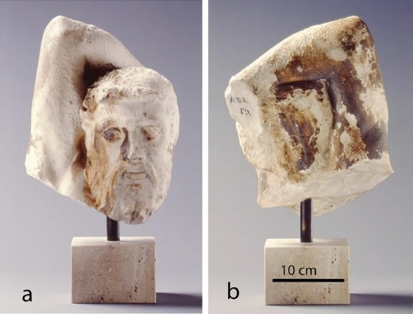

Books published in 2024

"Polychroma: The Meaning of Colours in Roman Sculptures"
directed by Elisabetta Neri
Published by Silvana Editoriale
Long ignored, sometimes knowingly since the idea of its presence went against the ideals of a white and pure ancient sculpture spread after Winckelmann, the polychromy of classical and late sculptures and architecture has been the subject of important research programs for thirty years. Within this field of study, the book focuses on the specific characteristics of Roman imperial polychromy and its late developments (first century BC – sixth century AD) to question the technical features and the socio-cultural meaning of colours.
After an assessment of the studies on polychromy already carried out, this book presents the results of the EU-MSCA-IF PolyCHRoMA project, which documented traces of colours not immediately visible (lost colours) through the physico-chemical analysis on a corpus of sculptural and architectural elements from some major European and North African
museums (Musées royaux de Belgique, Palazzo Reale in Milan, Museo Nazionale in Ravenna, Musée de l’Arles antique, Musée Saint-Raymond de Toulouse, Bardo National Museum and various Tunisian collections). The systematic chronological and contextual study of these traces, before time ensures the loss of colours definitive, confirms that polychromy offers a new source for studying the cultural meaning of colour at the turn of the first millennium.
See a preview here.
More details here.
Published - 15/10/2024.
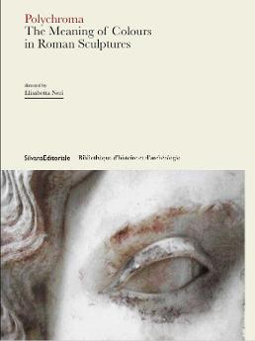

"La pierre, la couleur et la restauration: Le portail polychromé de la cathédrale d'Angers (XIIe-XXIe siècle). Contribution à l'étude des portails médiévaux en France et en Europe"
Bénédicte Fillion-Braguet, Nathalie Le Luel, Clémentine Mathurin and Marc Le Bourhis
Designed in the middle of the 12th century and a reference of early Gothic art, the portal of the Saint-Maurice Cathedral in Angers has sculpted and painted decoration which bears witness to the strong influence of the Royal Portal of Chartres.
In 2009, the cleaning of the portal confirmed the importance of the remains of polychromy of the portal made illegible by dirt and pollution. From 2009 to 2019, studies and then a restoration provided a lot of new data allowing a better understanding of the original decoration campaign and the general repainting of the 17th century.
More details here.
Published - 06/06/24.
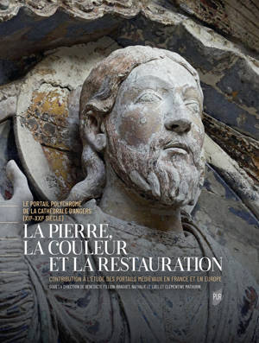

Archaeology of Colour Technical Art History Studies in Greek and Roman Painting and Polychromy (Meletemata 87)
Edited by Hariclia Brecoulaki
Published by National Hellenic Research Foundation.
Ancient polychromy speaks a language of “the visible” and “the invisible”, through signs of pigments, brushstrokes and forms. Another reminder of our classical past, colour is an inherent component of artistic creation, inspiration and imagination. New sophisticated technologies, as well as the development of interdisciplinary studies over these past decades, have stimulated the collection and evaluation of numerous scientific data from in-situ investigation of polychrome and painted documents, and have challenged our understanding of the complexity and function of ancient painting materials and techniques. The present volume is another contribution to the ongoing exploration of the rich history of colour in the classical world; an exploration which builds on previous knowledge and opens up new horizons for a more extended understanding of the aesthetics and meaning of Greek and Roman art. It includes fifteen papers that move from Archaic and Classical Greece to the Hellenistic and Roman periods, and deal with colour on monumental architecture, marble statues and reliefs, wooden and terracotta statuettes, stone sarcophagi, paintings on stone and plaster, and pigments as raw materials.
Read a preview here.
More details here.
Published - 06/24.
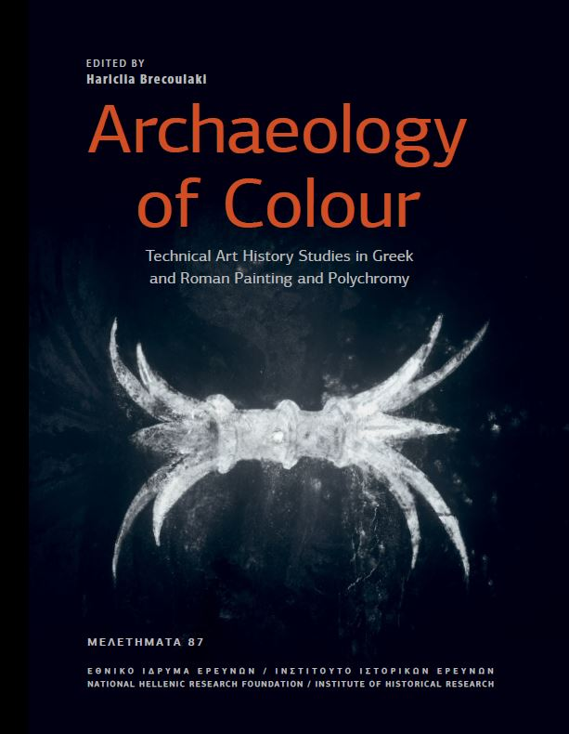

"Senses, Cognition, and Ritual Experience in the Roman World"
Blanka Misic, Abigail Graham (Editors)
Published by Cambridge University Press
How do the senses shape the way we perceive, understand, and remember ritual experiences? This book applies cognitive and sensory approaches to Roman rituals, reconnecting readers with religious experiences as members of an embodied audience. These approaches allow us to move beyond the literate elites to examine broader audiences of diverse individuals, who experienced rituals as participants and/or performers. Case studies of ritual experiences from a variety of places, spaces, and contexts across the Roman world, including polytheistic and Christian rituals, state rituals, private rituals, performances, and processions, demonstrate the dynamic and broad-scale application that cognitive approaches offer for ancient religion, paving the way for future interdisciplinary engagement.
More details here.
Published -25/01/24.

Articles, Books and Book Chapters published in 2023

"The goddess’ new clothes: the carving and polychromy of the Parthenon Sculptures"
Giovanni Verri, Hero Granger-Taylor, Ian Jenkins, Tracey Sweek, Katarzyna Weglowska and William Thomas Wootton
Antiquity, 2023, 97(395), 1173 - 1192.
Read open-access here: https://doi.org/10.15184/aqy.2023.130
Published online - 11/10/2023.
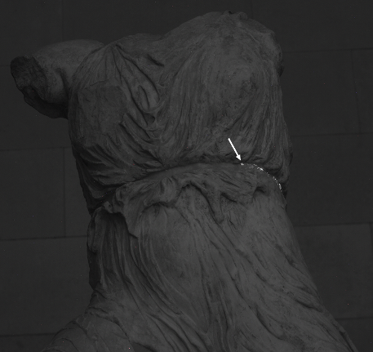

"Beyond “Volute Capitals”: Materials, Meaning, and Adaptations of a Phoenician Motif"
Fanni Faegersten and Carolina López-Ruiz
Journal of Eastern Mediterranean Archaeology and Heritage Studies, 2023, 11(2), 229-255.
Read more here: https://www.muse.jhu.edu/article/909073
Published online - 06/10/2023.
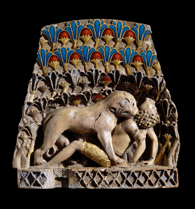

"The Colourant Mapping Project: approaching the evidence of colourant production in the Aegean during the Hellenistic and Roman Period through Kea, Kos and Rhodes"
Ariadne Kostomitsoupoulou-Marketou & Alexandra Rodler-Rørbo
Archaeol Anthropol Sci 2023, 15, 160.
Read more here: https://doi.org/10.1007/s12520-023-01849-7
Published online - 05/10/2023.

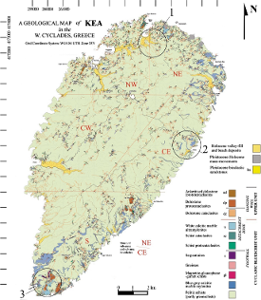

"Roman Clavus Decoration on Gallic Dress: A Reevaluation Based on New Discoveries"
Ursula Rothe, Anique Hamelink and Nicolas Delferrière
American Journal of Archaeology, 2023, 127(4), 545-562.
Read more here: https://doi.org/10.1086/725914
Published online - 13/09/2023.
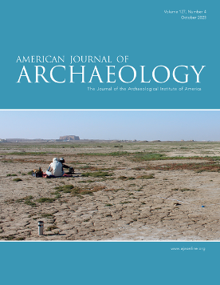

“Investigating Colors and Techniques on theWall Paintings of the ‘Tomb of the Philosophers’, an Early Hellenistic Macedonian Monumental Cist Tomb in Pella (Macedonia, Greece)”
Hariclia Brecoulaki, Giovanni Verri, Myrina Kalaitzi, Yannis Maniatis and Maria Lilimpaki-Akamati
Heritage 2023, 6(8), 5619-5647.
Read more here: https://doi.org/10.3390/heritage6080296
Published online - 28/07/2023.
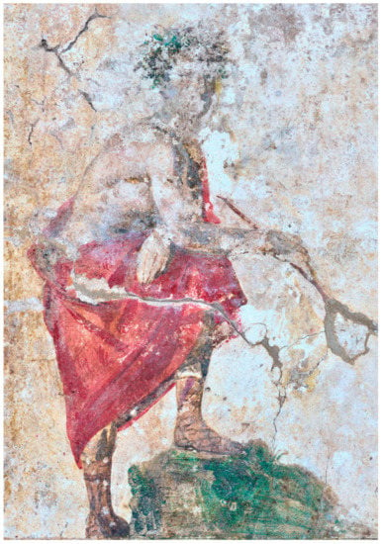

“Minerva in Colours: First Results on a Polychrome Roman Sculpture from Carnuntum (Pannonia)”
Gabrielle Kremer, Robert Linke, Georg Plattner, Eduard Pollhammer, Marina Brzakovic, Robert Krickl, Nirvana Silnovic and Václav Pitthard
Heritage 2023, 6(7), 5213-5241.
Read more here: https://doi.org/10.3390/heritage6070277
Published online - 11/07/2023.
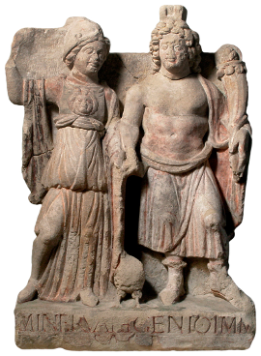

Article collection:
Proceedings from the conference on Ancient Science and Technology of colour: Pigments, dyes, drugs and their perception in Antiquity held at the University of Pisa on 28-29 April, 2022.
TECHNAI: An International Journal for Ancient Science and Technology
Published by Fabrizio Serra editore, Pisa · Roma
Volume 14, 2023
Includes:
*Vinzenz Brinkmann, Ulrike Koch-Brinkmann
Tracking blue. Some remarks on blue colour materials in the polychromy of ancient Greek sculpture (Open Access)
DOI: 10.19272/202310501002
*Giovanni Verri, Hariclia Brecoulaki
"From the face and the expression of the eyes": Multidisciplinary studies of pigments in ancient Greek and Roman painted surfaces (Open Access)
DOI: 10.19272/202310501003
*Agnès Rouveret
Certamen artis ac naturae. Couleurs et matières dans la définition plinienne de la peinture (Histoire naturelle, livre 35) (Open Access)
DOI: 10.19272/202310501004
*Chiara Ballestrazzi
The colours of gemstones in Pliny the Elder’s Natural History, Book 37 (Open Access)
DOI: 10.19272/202310501005
*Effie Photos-Jones
Pigments giving more than colour: The case of Lemnian earth or miltos (Open Access)
DOI: 10.19272/202310501006
*Maria Michela Sassi
A few remarks on the relationship between materials, technology and colour experience in ancient Greece (Open Access)
DOI: 10.19272/202310501007
Read the open access articles here.
Published online - 15/06/2023.
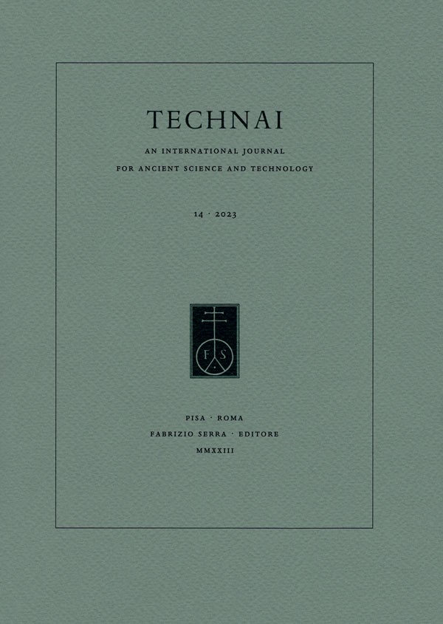

"Les figurines de Tarse. Partie III. Étude matérielle et analyses physico-chimiques"
Yannick Vandenberghe, Anne Bouquillon, Christel Doublet and Anne Maigret
Pallas 2023, 121, 129-142.
Read more here: https://doi.org/10.4000/pallas.26476
Published online - 17/05/2023.
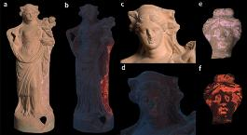

"Some Considerations on Recent Approaches to Cleaning, Conservation, and Display of Ancient Marble Sculptures from Historical Collections"
Federica Giacomini
Studies in Conservation 2023, 1-9.
Read more here: https://doi.org/10.3390/heritage6040197
Published online - 15/05/2023.

“Tracking Trajectories: Projecting Polychromy onto a Roman Relief from a Scottish Castle”
Louisa Campbell
Heritage 2023, 6(4), 3722-3744
Read more here: https://doi.org/10.3390/heritage6040197
Published online - 14/04/2023.
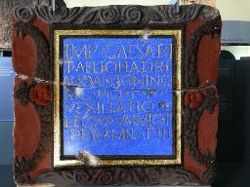

"Making and working Egyptian blue – a review of the archaeological evidence"
Ilia Kovalev, Alexandra S. Rodler, Cecilie Brøns and Thilo Rehren
Journal of Archaeological Science, 2023, 153, 105772.
Read more here: https://doi.org/10.1016/j.jas.2023.105772
Published online - 08/04/2023.
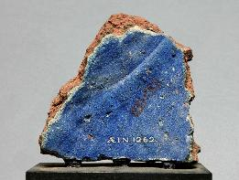

"New Evidence about the Polychromy of Early Imperial Cycle from the Augusteum of Rusellae (Tuscany)"
Paolo Liverani, Susanna Bracci, Roberta Iannaccone, Sara Lenzi and Donata Magrini
Heritage 2023, 6(4), 3385-3401.
Read more here: https://doi.org/10.3390/heritage6040179
Published online - 23/03/2023.
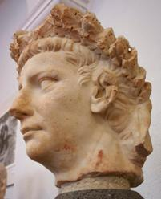

"Color and Light: A Hellenistic Terracotta Figurine of a Maenad from Myrina"
Brigitte Bourgeois, Giovanni Verri and Violaine Jeammet
Heritage 2023, 6(3), 3005-3024.
Read more here: https://doi.org/10.3390/heritage6030160
Published - 12/03/2023.

"Polychromy in Ancient Greek Sculpture: New Scientific Research on an Attic Funerary Stele at the Metropolitan Museum of Art"
Elena Basso, Federico Carò and Dorothy H. Abramitis
Appl. Sci. 2023, 13(5), 3102.
Read more here: https://doi.org/10.3390/app13053102
Published online - 28/02/2023.
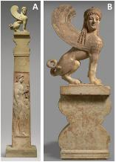

"The Gosford Wellhead: An Ancient Roman Masterpiece"
Seán Hemingway, with a contribution by Dorothy H. Abramitis, Federico Carò, and Adriana Rizzo
The Metropolitan Museum of Art Bulletin, v.80, no. 3 (Winter, 2023)
Read online or download the PDF, here:
https://www.metmuseum.org/art/metpublications/The_Gosford_Wellhead_An_Ancient_Roman_Masterpiece
Published - 08/02/23
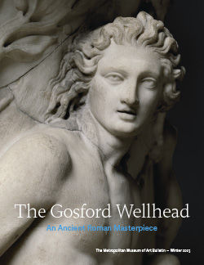
Books published in 2023

"Color and Meaning in the Art of Achaemenid Persia"
Alexander Nagel
Published by Cambridge University Press
This volume investigates the use of polychromy in the art and architecture of ancient Iran. Focusing on Persepolis, the topic is explored within the context of the modern historiography of Achaemenid art and the scientific investigation of a range of works and monuments in Iran and in museums around the world. Nagel's study contextualizes scholarly efforts to retrieve aspects of ancient polychromies in Western Asia and interrogates current debates about the contemporary use of color in the architecture and sculpture in the ancient Mediterranean world, especially in North Africa and the eastern Mediterranean.
More details here.
Published -14/09/23.
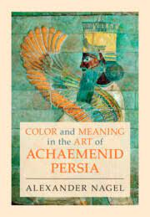

"Imperial Colors. The Roman Portrait Busts of Septimius Severus and Julia Domna"
J. Van Voorhis and M. Abbe (with J. G. Istrabadi)
Published by Giles, Ltd (London). In association with the S. and L. Eskenazi Museum of Art, University of Indiana. 2023.
A major new illustrated survey on two internationally significant Imperial Roman portrait busts. Imperial Colors focuses on the paired busts of Emperor Septimius Severus (r. 193-211) and his wife, Empress Julia Domna in the Eskenazi Museum of Art, two of the finest known examples of later Roman portrait sculpture. This book presents innovative multidisciplinary research .
More here: https://gilesltd.com/product/imperial-colors-roman-portrait-busts
Published - March 2023.
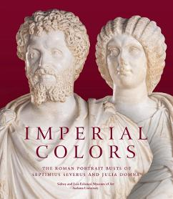

"Colour in Late Antique Art: An Aesthetic Exploration of Polychromy"
Bente Kiilerich
Published open-access on Academia.edu
Published - 13/04/2023.
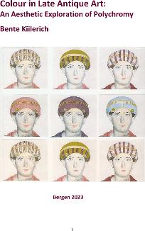
"Au Plaisir Des Dieux: Expériences Du Sensible Dans Les Rituels En Grèce Ancienne"
Adeline Grand-Clément
Published by Anacharsis Publishing
In ancient Greece the gods were omnipresent, from the clouds to the smallest sprig of rosemary. Rituals flourished. Soliciting deities was both frequent and extraordinary – and always possibly dangerous.
We know the procedures mobilized in these fragile moments of the "kitchen of sacrifice"; We are less informed about the range of senses that had to be awakened at the crucial moment of the encounter with the gods.
Adeline Grand-Clément embarks here on an investigation as close as possible to the feelings of the participants, meticulously seeking to grasp how darkness or light, colours, smells, touch, sounds or landscapes shaped specific sensory spaces, considered effective because they satisfy the pleasure of the gods.
More here.
Published - 03/03/2023.
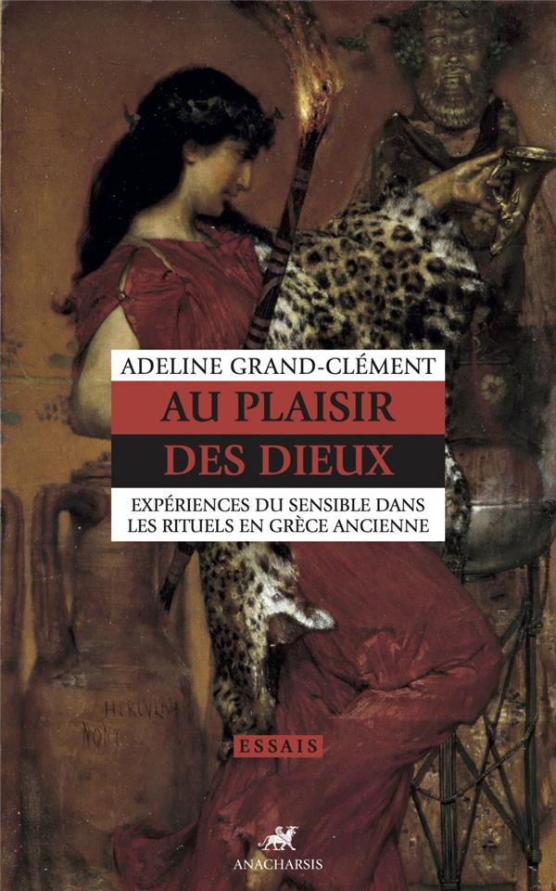

"The Colours of medieval English Alabaster Panels. Polychromy, production and perception" (English Edition)
Markus Schlicht, Aurélie Mounier, Maud Mulliez, in collaboration with Pascal Mora and Romain Pacanowski.
Published by Ausonius editions.
The book details the work of a multidisciplinary team on the analysis and reconstruction of the polychromy of several English alabaster panels preserved in the Bordeaux region, and is available online.
Download a free PDF copy of the book here.
Published - 31/01/2023.
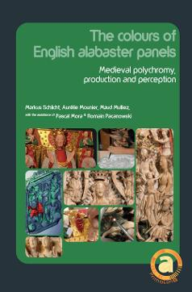
Publications - 2022

Articles & book chapters published in 2022

"The colours of Segesta. Searching for the traces of the lost pigments"
Veronica Ciaramitaro, Francesco Armetta, Monica de Cesare and Maria Luisa Saladino
Journal of Cultural Heritage, 59 (2023): 30-37.
Read more here: https://doi.org/10.1016/j.culher.2022.11.003
Published online - 20/11/2022.
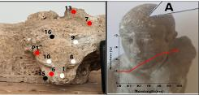

"A Late Archaic/Early Classical Greek Relief with Two Hoplites (Ny Carlsberg Glyptotek IN 2787)"
Jan Stubbe Østergaard and Adam Schwartz
Jahrbuch des Deutschen Archäologischen Instituts, 2022, 137, S. 1–37.
Read more here: https://doi.org/10.34780/1bb3-3a3d
To read a sample of the article (pp. 1 - 10), see:
https://reichert-verlag.de/media/pdf/9783752006650_sample.pdf
Published - 27/10/2022.
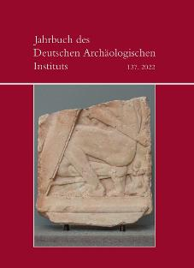

"Multi-technique analysis of pigments on sandstone sculptures: Renaissance re-painting of a Roman relief"
Louisa Campbell and Margaret Smith
Herit Sci 10, 156 (2022).
Read free and open-access here: https://doi.org/10.1186/s40494-022-00790-7
Published - 05/10/2022.
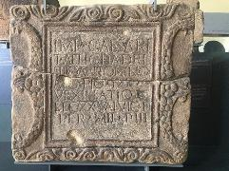

"Polychromy in Roman Portraits from Asido (Medina Sidonia, Cádiz, Spain). Livia, Germanicus and Drusus Minor"
Carlos P. Odriozola, José Beltrán Fortes, María Luisa Loza Azuaga and José María Martínez Blanes
Herit Sci 10, 108 (2022).
Read free and open-access here: https://doi.org/10.1186/s40494-022-00734-1
Published - 09/07/2022.
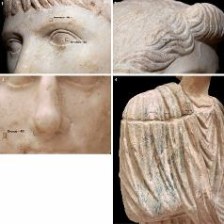

"Reconstructions of Roman Polychrome Architecture: Evidence, Ideal, and Ideology."
Stephan Zink
in Elisha Ann Dumser, and Dorian Borbonus (eds), Building the Classical World: Bauforschung as a Contemporary Approach (New York, 2022; online edn, Oxford Academic, 23 June 2022), https://doi.org/10.1093/oso/9780190690526.003.0014
More information on the volume here.
Published - 23/06/2022.
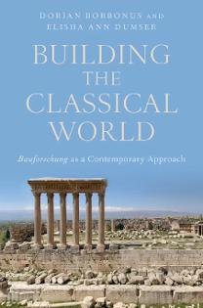
"Palmyrene Polychromy: Investigations of Funerary Portraits from Palmyra in the Collections of the Ny Carlsberg Glyptotek, Copenhagen"
Cecilie Brøns, Jens Stenger, Jørn Bredal-Jørgensen, Fabiana Di Gianvincenzo and Luise Ørsted Brandt
Heritage 2022, 5(2), 1199-1239.
Read free and open-access here: https://doi.org/10.3390/heritage5020063
Published - 01/06/2022.
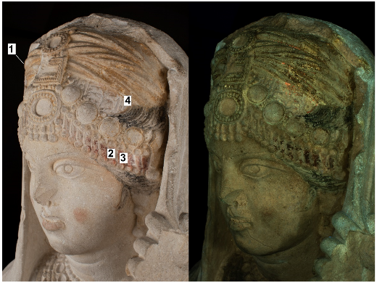

"Unveiling the paint stratigraphy and technique of Roman African polychrome statues"
Elisabetta Neri, Matthias Alfeld, Nesrine Nasr, Laurence de Viguerie and Philippe Walter
Archaeol Anthropol Sci 14, 118 (2022).
Read more here: https://doi.org/10.1007/s12520-022-01586-3
Published - 30/05/2022.
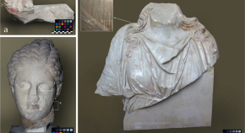

"Travel to Greece and Polychromy in the 19th Century: Mutations of Ideals of Beauty and Greek Antiquities"
Marianna Charitonidou
Heritage 2022, 5(2), 1050-1065.
Read free and open-access here: https://doi.org/10.3390/heritage5020057
Published - 19/05/2022.
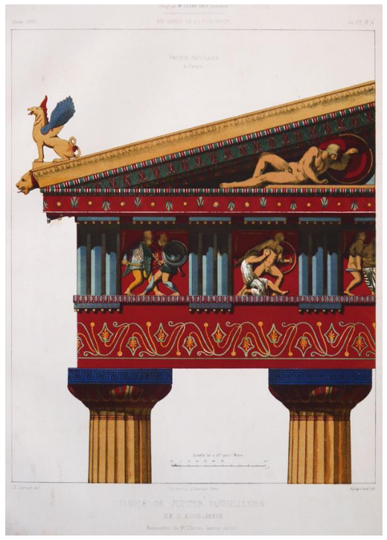

"Sensuous encounters: The adornment of cult statues in ancient Greece."
Cecilie Brøns
in Tomás García, J., & Sáenz-López Pérez, S. (eds.). (2022). Iconotropy and Cult Images from the Ancient to Modern World (1st ed.). Routledge. pp. 14-35.
This chapter examines the various evidence for the different forms of embellishment of ancient Greek cult images: their original polychromy, attachments such as metal ornaments, jewellery, and inlays, the use of textiles for dressing them, and treatments with waxes, oils and perfumes.
More information here.
Published - 07/04/2022.
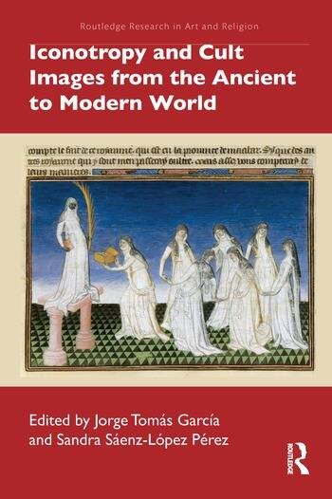

"Ancient Restoration in Roman Polychromy: Detecting Aesthetic Changes?"
Elisabetta Neri, Nesrine Nasr and David Strivay
Heritage 2022, 5(2), 829-848.
Read free and open-access here: https://doi.org/10.3390/heritage5020045
Published - 06/04/2022.
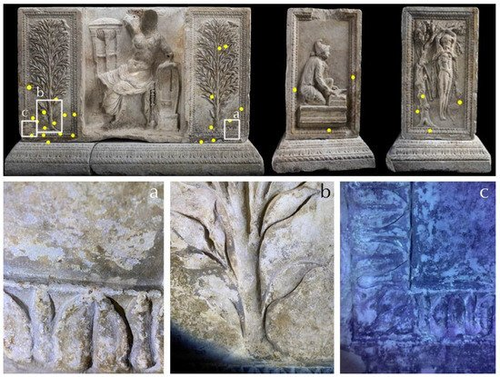

"Architectural Polychromy on the Athenian Acropolis: An In Situ Non-Invasive Analytical Investigation of the Colour Remains"
Eleni Aggelakopoulou, Sophia Sotiropoulou and Georgios Karagiannis
Heritage 2022, 5(2), 756-787.
Read free and open-access here: https://doi.org/10.3390/heritage5020042
Published - 01/04/2022.
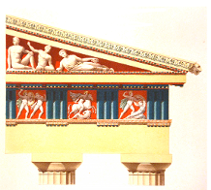

"An Insight into Gandharan Art: Materials and Techniques of Polychrome Decoration"
Anna Lluveras-Tenorio, Alessia Andreotti, Fabio Talarico, Stefano Legnaioli, Luca M. Olivieri, Maria Perla Colombini , Ilaria Bonaduce and Simona Pannuzi
Heritage 2022, 5(1), 488-508.
Read free and open-access here: https://doi.org/10.3390/heritage5010028
Published - 02/03/2022.
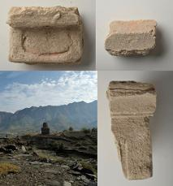

"Microscopic-Scale Examination of the Black and Orange–Yellow Colours of Architectural Glazes from Aššur, Khorsabad and Babylon in Ancient Mesopotamia"
Fanny Alloteau, Odile Majérus, Floriane Gerony, Anne Bouquillon, Christel Doublet, Helen Gries, Anja Fügert, Ariane Thomas, and Gilles Wallez.
Minerals 2022, 12(3), 311.
Read free and open-access here: https://doi.org/10.3390/min12030311
Published - 28/02/2022.
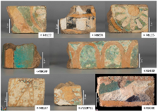

"What were the colors of the Parthenon? Investigation of the entablature's cornice blocks"
Eleni Aggelakopoulou, Asterios Bakolas
Journal of Archaeological Science, 2022, 105553.
Read free and open-access here: https://doi.org/10.1016/j.jas.2022.105553
Published - 10/02/2022.
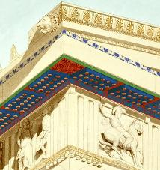

"An evergreen blue. Spectroscopic properties of Egyptian blue from pyramids to Raphael, and beyond"
Antonio Sgamellotti and Chiara Anselmi
Inorganica Chimica Acta, 2022, 530, 120699.
Read more here: https://doi.org/10.1016/j.ica.2021.120699
Published - 24/01/2022.


Books published in 2022

"Seeing Color in Classical Art: Theory, Practice, and Reception, from Antiquity to the Present"
Jennifer M. S. Stager
Published by Cambridge University Press
The remains of ancient Mediterranean art and architecture that have survived over the centuries present the modern viewer with images of white, the colour of the stone often used for sculpture. Antiquarian debates and recent scholarship, however, have challenged this aspect of ancient sculpture. There is now a consensus that sculpture produced in the ancient Mediterranean world, as well as art objects in other media, were, in fact, polychromatic. Colour has consequently become one of the most important issues in the study of classical art. Jennifer Stager's landmark book makes a vital contribution to this discussion. Analyzing the dyes, pigments, stones, earth, and metals found in ancient art works, along with the language that writers in antiquity used to describe colour, she examines the traces of colour in a variety of media. Stager also discusses the significance of a reception history that has emphasized whiteness, revealing how ancient artistic practice and ancient philosophies of colour significantly influenced one another.
More here.
Published - 25/11/2022.
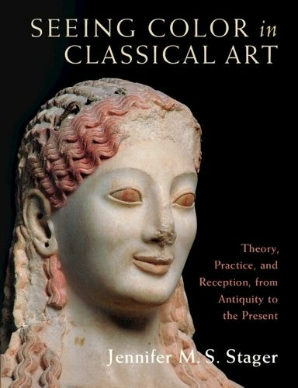

"Bisanzio a colori. La policromia nella scultura bizantina"
Silvia Pedone
Published by Bardi edizioni
More here.
Published - 2022.
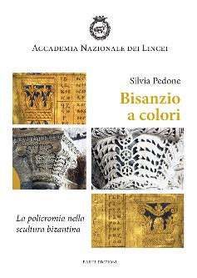

Die Suche nach einem angemessenen Bild der Geschichte: Re-Inszenierung und Rekonstruktion der Antike in Schrift, Form und Farbe von J. J. Winckelmann bis heute.
[The search for an appropriate picture of history: re-enactment and reconstruction of antiquity in writing, form and colour from J. J. Winckelmann to the present day.]
Katharina Mann
Published by De Gruyter
The publication focuses on the relationship between needs-oriented images of history and the adoption of historical artistic styles. The congruence of re-enactment or reconstruction and the collective desire for a representative image of their own past is analyzed with respect to the interaction between zeitgeist, influential protagonists, and historicizing ideologies. Critical light is shed on various dogmas, such as the idea of a beautifully white antiquity, which still has an effect on our contemporary imagination. Even though color reconstructions can help us re-examine our aesthetic perceptions, it is still unclear whether and how we want to work with preconceived notions in the context of new societal challenges.
More information here.
Published - 22/08/2022.

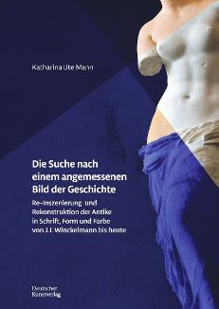

"The Polychromy of Etruscan Sculpture on the basis of selected objects from European Museums" (Doctoral Thesis)
Julia Großekathöfer
Published by Ruhr-Universität Bochum.
This publication is based on the visual examination and photographic
documentation of more than seventy-five exemplary Etruscan objects. This alone gives the reader a first insight into the aesthetic and narrative functions of colour in Etruscan sculpture. The text section focuses on the evaluation of the material, while the catalog illustrates the description of the objects. Finally, a tabular overview provides the basis for determining more precisely the painting technique of an Etruscan object in its dependence on form and time.
Dr Großekathöfer obtained her doctorate on 22 July 2016 and is currently doing a scientific traineeship - in addition to her work as a museum educator - at the LWL-Römermuseum Haltern am See.
Open access to the book is available here.
Published - 07/03/2022.
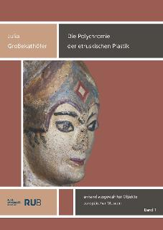

"Textiles in Ancient Mediterranean Iconography"
Editors: Cecilie Brøns, Susanna Harris, Marta Żuchowska
Published by Oxbow Books.
This volume provides an ambitious synopsis of the complex, colourful world of textiles in ancient Mediterranean iconography. A wealth of information on ancient textiles is available from depictions such as sculpture, vase painting, figurines, reliefs and mosaics. Includes several chapters on polychromy in ancient sculpture.
More information (including how to order) here.
Open access to the book is available here.
Published - 28/02/2022.
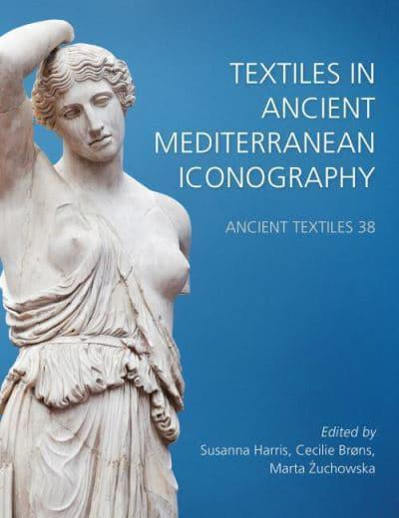
Publications - 2023

Articles & book chapters published in 2021

"Portrait of an Etruscan Athletic Official: A Multi-Analytical Study of a Painted Terracotta Wall Panel"
Monica Ganio, Douglas MacLennan, Marie Svoboda, Claire Lyons and Karen Trentelman.
Heritage, 2021, 4(4), 4596-4608.
Read free and open-access here: https://doi.org/10.3390/heritage4040253
Published - 28/10/2021.

"Wax finishing in Roman polychrome statuary: Ganosis on the colossal head from Dougga (Tunisia)"
Elisabetta Neri, Caroline Bouvier, Laurence de Viguerie, Alain Brunelle, Nesrine Nasr, Fathi Béjaoui, François Baratte and Philippe Walter
Journal of Cultural Heritage, 2021, 51, 29-36.
Read more here: https://doi.org/10.1016/j.culher.2021.06.013
Published - 25/07/2021.
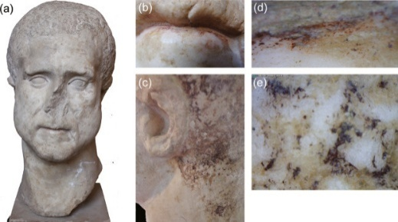

"Re-presenting in Colours at the ‘Palace of Nestor’: Original Polychromy and Painting Materials"
Hariclia Brecoulaki, Andreas G. Karydas, Vassilis Perdikatsis and Maria P. Colombini
in J. Bennet (ed.), Representations. Material and Immaterial Modes of Communication in the Bronze Age Aegean, Sheffield Studies in Aegean Archaeology, Oxford, Oxbow Books, 2021, 53-106.
More information (including how to order) here.
Published - 15/05/2021.
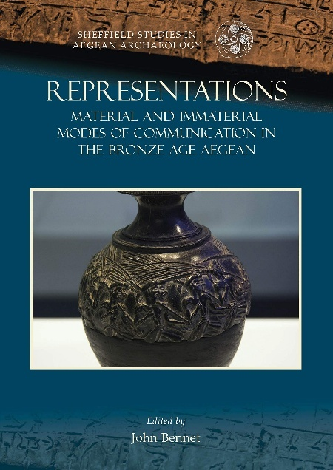

"Art."
Mark Abbe
and
"Architecture and Interiors"
Stephan Zink
in D. Wharton (ed.), A Cultural History of Color in Antiquity, (A Cultural History of Color, vols. 1-6, edited by C. P. Biggam and K. Wolf). London: Bloomsbury Press. 2021. 135-154 and 155-176.
More information here.
Published - 11/02/2021.
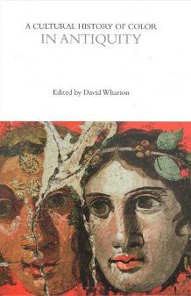

Books published in 2021
"The Painted Tetrarchic Reliefs of Nicomedia: Uncovering the Colourful Life of Diocletian’s Forgotten Capital"
Tuna Şare Ağtürk
Published by Brepols.
The book presents the very first discussion of an astonishing group of painted Roman reliefs discovered from an imperial complex, at the centre of Diocletian’s empire at Nicomedia.
More information (including how to order) here.
Published - 25/11/2021.
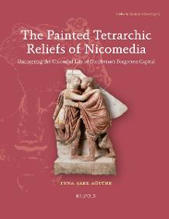

"Les couleurs des albâtres anglais. Polychromie, production et perception médiévales"
Markus Schlicht, Aurélie Mounier, Maud Mulliez,in collaboration with Pascal Mora and Romain Pacanowski.
Published by Ausonius editions.
The book details the work of a multidisciplinary team on the analysis and reconstruction of the polychromy of several English alabaster panels preserved in the Bordeaux region, and is available online.
Download a free PDF copy of the book here and a short video summary here.
Published - 08/11/2021.
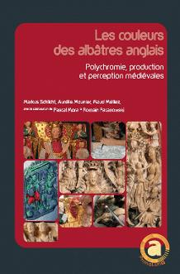

"The Nature of Art: Pliny the Elder on Materials"
Andreas Grüner, Anna Anguissola (eds.)
Published by Brepols.
This volume of collected essays addresses the presentation of artistic processes and their materials in the Natural History and focuses on the issues that lie at the root of Pliny's work: his account of the technological, economical, ideological, and aesthetic aspects of materials.
More information here.
Published - 30/06/2021.
