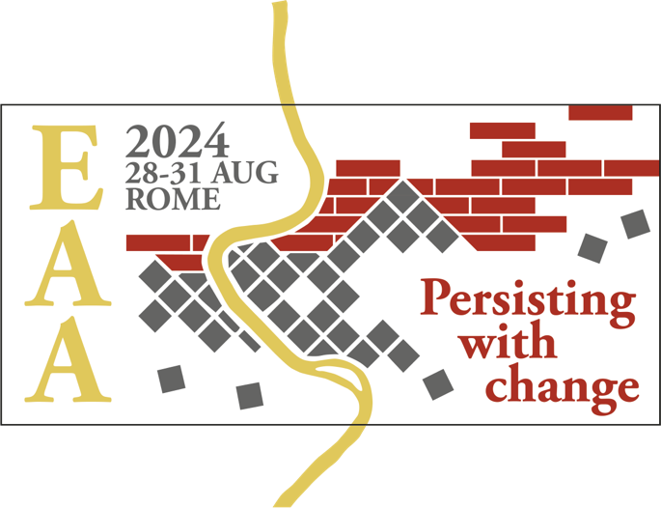
Come join us at the 30th Annual Meeting of the
European Association of Archaeologists #EAA2024

Theme 1: The Material Record:
Current Trends and Future Directions
Regular Session: #723

Egyptian Blue – From Literature to the Artifact to the Lab

Keywords: ancient pigments and polychromy, production technology, material provenance

As the first artificial pigment, Egyptian blue has a millennia-long history of production, processing, working, and use. Throughout its impressive life history, this material has been used for making small objects, such as mosaic tesserae, for painting walls, for sculptures or architectural elements, and as a cosmetic.

Experimental archaeology, archaeometry, and research into ancient texts make it possible to understand more about how this first synthetic pigment was made, distributed, and used. The small chemical and physical variations revealed by these first two techniques, combined with a deep knowledge of the written record, is the key to constructing historical narratives about Egyptian blue.

Technological choices in ancient production practices and the provenance of resources are interesting meeting points for discussing cultural change and trade interactions in human history. An interdisciplinary dialogue between archaeologists and natural scientists is desirable to address challenges related to the analysis of archaeological materials.

Please contact us
if you have any questions
We invite contributions that inspire this dialogue and discuss their work on the development of analytical instruments and techniques, experimental approaches, analysis of production technology and material provenance.

Organisers:
Anthony Baragona (University of Applied Arts Vienna) – tonybaragona@gmail.com
Alexandra Rodler-Rørbo (Austrian Archaeological Institute) – alexandra.rodler-rorbo@oeaw.ac.at
Hilary Becker (Binghamton University) – hbecker@binghamton.edu
Giovanni Verri (Art Institute of Chicago) – gverri@artic.edu
Ariadne Kostomitsopoulou Marketou (Norwegian School of Theology, Religion, and Society) – ariadne.k.marketou@mf.no

